Dear Applicant:

Personal Data Protection Statement For Applicants

In the course of your application for the 22nd Ayala Young Leaders Congress (AYLC 2020) with Ayala Corporation, acting through Ayala Foundation, Inc. (together, the “Companies”), the Companies will obtain or collect from time to time, personal data from you or in relation to you (“Personal Data”). Please note that your Personal Data will be collected, processed, used and stored for purposes directly or indirectly relevant to your application for AYLC. Your Personal Data may also be used for the Companies’ administration and management of applicants and for compliance with applicable laws and regulations.

By signing and returning this Consent Form to the Companies, you confirm that you consent to the collection, use, recording, storing, organizing, consolidation, updating, disclosure, transfer, sharing and/or general processing of your Personal Data by the Companies as stated above and you undertake in turn to help the Companies to observe the requirements of the Data Privacy Act of the Philippines (Republic Act No. 10173), its implementing rules and regulations and other relevant issuances of the National Privacy Commission. The permission you are granting to the Companies shall be effective immediately and shall continue for a period of one (1) year from the date of this consent form (the “Permission Period”), unless you inform us in writing of your decision to revoke your permission prior to the end of the Permission Period, in which case, the Companies shall immediately cease from collecting, using, recording, storing, organizing, consolidating, updating, disclosing, transferring, sharing and/or general processing of your Personal Data.

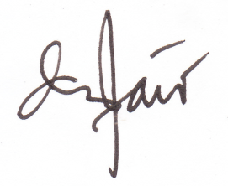
Very truly yours,

May Anne M. Montano
AYLC Program Lead

Consent:

I hereby consent to the collection, use, recording, storing, organizing, consolidation, updating, disclosure, transfer, sharing and/or general processing of my Personal Data by the Companies in accordance with the terms of this Personal Data Protection Statement for Applicants.

__________________________________ ___________________
Applicant’s Name and Signature Date

